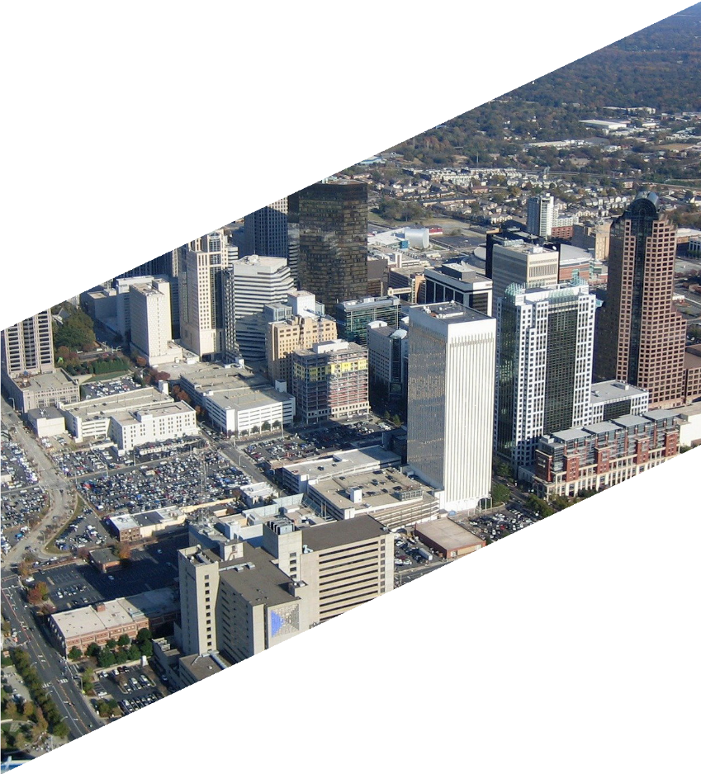

NORTH CAROLINA DEPARTMENT OF INFORMATION
TECHNOLOGY BROADBAND INFRASTRUCTURE OFFICE

Digital Inclusion Plan
T E M P L A T E A N D G U I D E

Introduction How to use
this document

Congratulations! If you are embarking on building a digital inclusion plan, your community is committed to prioritizing digital inclusion. Creating a digital inclusion plan is a perfect first step to ensure your community becomes more
digitally equitable. The Broadband Infrastructure Office of the North Carolina Department of Information Technology in partnership with the National Telecommunications and Information Administration developed this template and
guide to support North Carolina communities as they develop digital inclusion plans and digital equity strategies.

While the digital divide was present and pervasive throughout North Carolina prior to the COVID-19 pandemic, the stay-at- home orders that pushed more activities online than ever quickly exposed to the world what many of us knew already— the internet and its benefits are not accessible to all North Carolinians. While the pandemic has impacted us all, those without internet, a computer, and the skills to use them have been disproportionately impacted during this time. As such, closing the digital divide is more imperative now than
ever before.

‘Digital Equity’ is a condition in which all individuals and communities have the information technology capacity needed for full participation in our society, democracy, and economy. As the world has learned since the beginning
of 2020, digital equity is necessary for civic and cultural participation, employment, lifelong learning, and access to essential services. Digital Inclusion activities will help your community reach digital equity. Digital Inclusion activities are the activities necessary to ensure that all individuals and communities, including the most disadvantaged, have access to and use of Information and Communication Technologies (ICTs).

This document will help your community form a ‘digital inclusion plan’ to help guide your community design and implement digital inclusion activities and increase digital equity. Building a digital inclusion plan is similar to building a community strategic plan. The primary difference is a digital inclusion plan specifically addresses the digital divide and identifies strategies to close it. Like any plan, a plan is built from a specific place in time, reflects the community it is developed in, and is not the end in itself—but points to and prepares the way for your final goal—a digitally
equitable community.
Your community may choose to use this document as a loose guide or follow it to the letter. Regardless, our hope is that
it simplifies the process of creating a plan and helps your community implement the plan faster, thereby increasing digital equity in your community faster.

Closing the digital divide has never been more urgent, and we hope this template enables your community to meet the needs of your community members, leverage your
community’s unique assets, and find innovative and creative solutions for closing the digital divide in your community.

This document includes both a template with the specific categories your team should consider including in your plan as well as a guide with probing questions to assist your community in the process of building that plan. Whether you simply fill out the basic template, or use the guide to walk through the provided questions before synthesizing the information into a plan will depend on how much planning and work your community has already done, in addition to your community’s individual needs, timeline and capacity.

First, you will find a digital inclusion plan template. While each community may choose to structure and order their plan differently, this is the general order and list of categories we recommend each plan include.

The second aspect of the document is a guide that expands the template with questions, comments, and things to consider as you build your plan. Notably, the order of this section is different from the template. This is because the chronological order in which you compile the plan will likely differ from the order it appears in its final form. For example, it is often easier to create goals after you have identified your community’s assets and gaps.

Both the template and guide were designed to incorporate the common themes and challenges communities who embark on digital inclusion work encounter. But it may not address some of the specific challenges or opportunities in your community. As such, this guiding document is what
it sounds like—a guide. While we hope it is a useful tool in your planning process, given North Carolina’s geographic and cultural diversity, it will not address every community’s
unique circumstances. Please feel free to use this as is, tweak it to your needs, or compile your own plan from scratch.

2
We hope this tool supports your community as you embark
on closing your community’s digital divide and creating a digitally equitable community where all citizens are equipped with the technology, tools and training needed to thrive in the 21st century.

The Community
Digital Inclusion Plan Template

Collective Vision for Digital Inclusion in your Community
  - Vision Statement
  - Mission Statement
  - Values
  - Goals
    - Alignment with existing community goals and plans (including community and economic development goals/plans)
    - Digital inclusion specific goals
  - Objectives

Current State of Digital Inclusion and Digital Divide in your Community
  - Asset Inventory
    - Broadband assets
      - Mobile broadband
      - Fixed broadband
      - Public Wi-Fi or public access points
      - Wi-Fi mobile hotspot lending programs
      - Discount/low-cost offer programs
    - Digital literacy/skills opportunities
      - Organizations specializing in digital literacy training
      - Workshops
      - Courses
    - Individual support
      - Digital navigators
      - Tech support
    - Public computer access points
    - Computer/devices
      - Refurbished
      - Low-cost
      - K-12
      - Other
    - Other/Miscellaneous
  - Needs Inventory
    - Broadband availability
    - Broadband subscription
    - Broadband affordability
    - Computers/devices
    - Digital literacy/skills
    - Other
  - Partner Identification
  - Gap Assessment

Implementation: Achieving a Collective Digital Inclusion Vision in your Community
  - Strategies
    - Leadership
    - Sustainability
    - Holistic response
    - Prioritization
    - Necessary resources
  - Timeline
    - Short-term
    - Near-term
    - Long-term

3

The Community Digital Inclusion Plan Guide:
Supplemental Questions and Instructions for Developing your Plan

NOTE: The following guide is meant to guide you and your community through the process of creating your digital inclusion plan. The guide expands on the template and is in a different order. This is because it is often easier to build a plan with a better understanding of what assets and gaps your community has. However, your community may determine starting with the visioning process of this guide will better
suit your needs. This guide is meant to be structured in the way that best meets your community’s needs. As you document your assets you may find that some assets fit
into multiple categories—that’s to be expected. Feel free to organize and categorize the assets in a way that best suits your community’s needs.

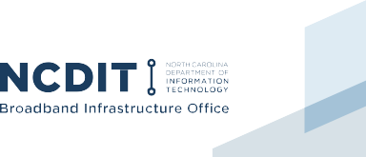
Assets and Gap Inventory
4
  - Asset Inventory: In this section you will catalogue your community’s unique assets. This can be a mix of hard assets (i.e. computer labs, downtown wi-fi, hotspot lending programs, etc.) and soft assets— the people, organizations, digital skills/literacy trainings, etc. that are unique to your community.

Note that later in this process, you will identify the gaps or what is unavailable. In this section, focus on what is available.
    - Broadband Assets: Where is broadband available in your community, and are there options and programs to address its affordability?
      - Mobile or Cellular Service-Who is your predominant mobile/cellular provider?
        - Do you have coverage maps of their service areas? (NOTE: If not, contact NC BIO to obtain more information)
        - For data on the percent of your households/ population with access to mobile or cellular service contact www.ncbroadband.gov
      - Fixed or Wireline Service: What internet service providers serve your community?
        - Do you have coverage maps of their service areas? (NOTE: If not, contact NC BIO to obtain more information)
        - For data on the percent of your households/ population with access to fixed or wireline service contact www.ncbroadband.gov
      - Public Wi-Fi or public access points: Where in your community can community members access free public Wi-Fi (i.e. Some examples might be:
        - Parks
        - Libraries
        - School parking lots
        - Restaurants/grocery stores etc.
        - Churches and places of worship
        - Career Centers
      - Personal Wi-Fi Hotspots: Does any organization ‘lend’ or ‘check-out’ mobile hotspots to citizens? If so, how many do they have available? Some examples might be:
        - K-12 Schools
        - Libraries
        - Community Colleges and universities
      - Discount or Low-Cost Programs: Do any of your internet service providers offer discount or low-cost service for low-income families? See here for examples.
    - Digital Literacy/Skills: What programs and organizations currently provide the following in your community/region?
      - Digital skills or digital literacy
        - Workshops
        - Courses
        - One-on-one sessions
      - Workforce development training (computer/ digital skills focused) Job search training or assistance that includes digital skills/product development (i.e. resumes, etc.)
      - STEM/STEAM training
      - Coding schools, certifications, or training
      - Technical certifications

    - Public Computer Access: Where in your community can the public access computers? You may want to map these locations and catalogue how many computers are available at each location.
      - Public computer centers
      - Libraries
      - Workforce development centers
      - Afterschool programs
      - Recreation centers
      - Mobile computer labs
      - Churches/places of worship
      - Other
    - Individual Support: Where in your community can the public obtain individual assistance and support?
      - Digital Navigators: Where in your community can the public access assistance in navigating the digital inclusion process?
        - Is there a person or organization who provides information on home internet connectivity, devices, and digital skills?
        - Navigators can be members of the community, volunteers or cross-trained staff who already work in social service agencies, libraries, health, as well as others who
offer remote and socially distant in-person guidance.
        - For more information see NDIA’s Digital Navigator Model
      - Tech Support: Do any organizations or groups of organizations provide cost-free or low- cost tech support to new computer users or refurbished computer owners?
    - Devices: Where in your community can the public obtain low-cost or no-cost computers?
      - Does your K-12 school system have a one-to- one computer program? (i.e. provide laptops/ tablets for students)
        - If so, what type of devices does your school system use?
        - How many grades have access to these devices?
        - Can the students take the devices home or do they stay at school?

        - Are there fees charged for full participation in the one-to-one program?
          - Do your libraries check out or ‘loan’ computers?
          - Do your community colleges check out or ‘loan’ computers?
          - Is there an organization that provides refurbished, discounted, or low-cost devices? See here for examples.
    - Other/Miscellaneous: Does your community have any other digital inclusion assets, or assets that can be leveraged for digital inclusion?
  - Needs Inventory: In this section you will catalogue your community’s unique digital inclusion needs. To do so, you’ll evaluate how and where the various aspects of the digital divide impact your community.
    - Broadband Availability: where is broadband unavailable in your community?
      - To identify broadband availability gaps in your community, visit https://www.ncbroadband. gov/indices/ and view the “Broadband Availability and Quality Index” for the county or census tracts
      - For broadband coverage of your community, visit: https://www.nconemap.gov/pages/ broadband
      - If your community has previously conducted a survey or feasibility study, you can use that data here.
      - If you need more granular data, your team can partner with NC BIO to distribute its standardized survey and speed test to your citizens. See here for more information.
    - Broadband Subscription: what is your community’s subscription rates? Who subscribes and who does not?
      - To identify subscription rates in your community, visit: https://www.ncbroadband. gov/indices/ and view the “Broadband Adoption Potential Index” for the county or census tracts
      - Use ‘% Broadband Subscription’ data point and overall adoption potential score.

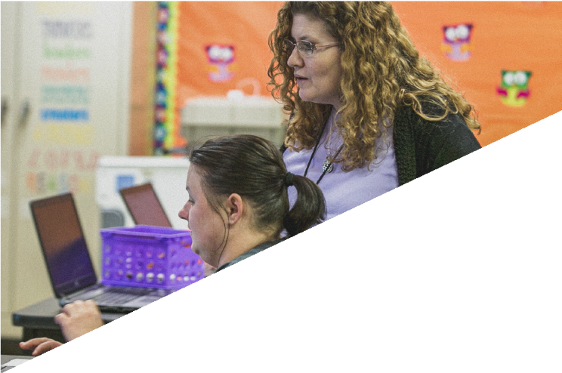

5

    - Broadband Affordability: is broadband affordable in your community? How many households in your community are low-income and may not be able to afford the service that is available?
      - To identify broadband affordability challenges, visit https://www.ncbroadband. gov/indices/ and view the “Broadband Adoption Potential Index” for the county or census tracts
      - Use ‘% Poverty’ data point.
    - Computers/Devices: how many households in your community do not have access to a desktop, laptop, tablet, or other computer?
      - To identify computer and devices gaps, visit https://www.ncbroadband.gov/indices/ and view the “Broadband Adoption Potential Index” for the county or census tracts
      - Use ‘% Households No Computer Devices’ data point.
    - Digital Literacy/Skills: how many households in your community do not have the skills needed to effectively use the internet or digital devices?
      - This data is difficult to obtain, but you can use proxy data such as levels of education, or the percent of your population with
limited English.
      - In addition, you may consider obtaining anecdotal data from community partners that provide computer access and assistance to people who need help with computer tasks such as librarians, workforce development centers, etc. They may be able to provide information on the demographics with the highest digital skills needs and the needs they believe to be most pronounced.
      - To identify Digital Literacy and skills gaps, visit https://www.ncbroadband.gov/indices/ and view the “Broadband Adoption Potential Index” for the county or census tracts
  - Partners: In this section you will identify the organizations within your community who can partner with your organization to close your community’s digital divide.
    - What organizations, if any, already provide digital inclusion services in your community?
    - What organizations, if any, could/should get involved in digital inclusion efforts? Some examples might be:
      - County government leaders
      - Local government leaders
      - K-12 school system
      - Libraries
      - Community college
      - Public housing authorities
      - Local universities and colleges
      - Non-profits
      - Chamber of commerce
      - Entrepreneurs and business owners
      - Churches and faith-based institutions
      - Local foundations and funders
      - Local internet service providers
  - Identifying gaps: You have now identified your assets, needs, and partners. This section will help you identify both the gaps in your understanding of digital inclusion in your community and who
is not currently served by your digital inclusion ecosystem.
    - Who are the populations in need in your community that are unserved by the current digital inclusion ecosystem?
      - Are there certain demographics (age, income, race/ethnicity, language, disability) that are unserved?
      - Are there certain geographic areas (neighborhoods, cities, towns, rural areas) that are unserved?
    - What information is missing? What other data or information is needed to inform your plan?
      - If you find you need more granular broadband availability and adoption data, you can partner with NC BIO to deploy a standardized survey and speed test to gather more granular availability and adoption data in your community:
      - Survey information can be found here: https://ncbroadband.gov/survey

6

Collective Vision for Digital Inclusion in your Community
In this section, your community will collectively imagine what your community could look like if digital equity is achieved and cast a vision for what digital equity looks like in your unique context. Your community’s collective vision section may include all the following components (vision, mission, values, goals, and objectives) or just a few of them. Outlined below are the different components it could include and probing questions to help you develop the components you choose to include.

  - Vision: a vision statement is your north star for the plan. It is a ‘clear, specific, compelling picture’ of what your collective vision is for the future of your community. In this context, it is a collective vision for what your community would look like if it were digitally equitable.
    - To develop the plan’s vision statement for the digital inclusion plan, consider the following questions (in a group or individually):
      - How does the digital divide impact your community?
      - Why is digital inclusion important to your community? It may be helpful to think about the following two scenarios:
        - If we do nothing, what does the future look like?
        - If we do this correctly, what does the future look like?
    - Using your responses to the questions above, develop a short collective, community vision statement for your digital inclusion plan.
  - Mission: a mission statement is a general statement on how the vision will be achieved.
    - To develop the plan’s mission statement, consider the following questions (in a group or individually):
      - What does your community plan to do to close the digital divide?
      - How will your community close the digital divide?
      - For whom does your community seek to close the digital divide?
      - What value will this plan bring to closing your community’s digital divide?
    - Using your responses to the questions above, develop a short collective, community mission statement for your digital inclusion plan.
  - Values: values are the distinctive and enduring principles your community will follow in designing and implementing the plan. Your community may find it appropriate to embed values into the plan so as digital inclusion programs are implemented because of the plan, they are built on common values.
    - To develop the plan’s values, consider the following questions (in a group or individually)?
a. How does digital inclusion align with your community’s existing values?
    - What beliefs should guide the goals and the subsequent activities that result from the plan?
  - Goals: the plan’s goals will be broad, intangible outcomes that are derived from and support the achievement of the community vision statement.
    - Alignment with existing community goals and plans: To develop the plan’s goals, your team will first need to identify how the plan’s goals align with your community’s existing goals and plans. As a group, consider the following questions:
      - How does digital inclusion align with your community’s existing goals and plans?
      - Does your community already have a strategic plan or a community economic development plan?
      - If so, how will digital inclusion activities help achieve the goals outlined in your plan(s)?
      - For example, if your community has established goals around any of the following issues, consider how digital inclusion activities would enhance (or detract from) your goals.
        - Aging in place
        - Health
        - Community and economic development
        - Education
        - Public safety
        - Quality of Life
    - Develop digital inclusion specific goals:
      - To create digital inclusion goals that align

7

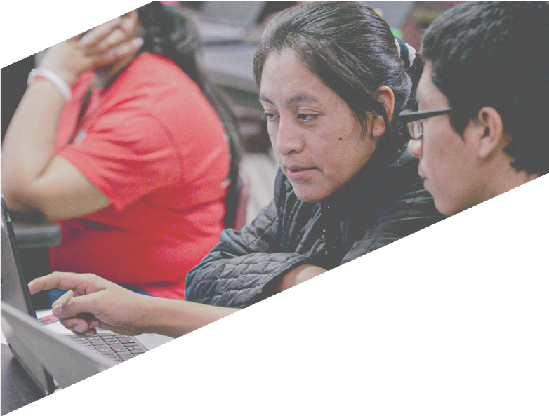
with your community’s existing goals, it may be useful to create goals to address each aspect of the digital divide: broadband access, broadband affordability, computer devices, and digital literacy.
information and resources
c. How will you address the lack of computers or devices in your community?
d. How will you address digital literacy and digital skills needs?
8
      - To develop your digital inclusion goals, consider the following questions as a group for each aspect of the digital divide:
        - What do we want to achieve in a year? In five years? In ten years?
        - What do we need to do to get there?
        - Who do we need to serve? I.e. Who is most impacted by the digital divide in
our community?
  - Objectives: objectives are specific, measurable, concrete, and support the obtainment of
your goals.
    - Each goal you develop may have several objectives to reach that specific goal. For example, if your goal is ‘to ensure all K-12 students have access to a meaningful computing device in their home by 2021’ then your objectives might be the following: a. Determine how many students do not have a computing device at their home by Dec. 2020. b. Identify
the number of computing devices the school system deploys to students through the current 1:1 program by Dec. 2020; c. Purchase devices for 100 percent of K-12 students without devices by April 2021.
    - Objectives help you measure your progress towards achieving your goals. Including objectives will assist your team in determining how impactful your strategies are at achieving your goals.

Implementation
  - Strategies: To develop the strategies you will undertake to achieve your goals, consider the following questions.
    - Remembering that the digital divide impacts each facet of your community in unique ways and as such each part of your community will need to address digital inclusion within their sphere, how will you integrate digital inclusion into the various agencies, sectors and industries in your community? (ie. community & economic development, healthcare, education, public safety, etc.)
    - Who will lead the efforts, keep projects on schedule and help your community implement the various aspects of this plan?
      - Many communities find it helpful to create a digital inclusion coalition to lead these efforts. If your community does not already
have a coalition, forming one could be one of the outcomes of this plan.
      - For information on how to form a coalition, see the NDIA’s Digital Inclusion Coalition Guidebook.
    - How will your community achieve the goals you outlined above?
    - How will you plan for sustainability for each strategy? For example, some projects may be one-time short-term projects, where-as others will necessarily span years. How will you ensure those long-term efforts have the funding and support needed to be sustainable?
    - How will you holistically address the various aspects of the digital divide?
      - How will you address broadband access?
      - How will you address broadband affordability?
        - See NDIA Discount Internet Guidebook for

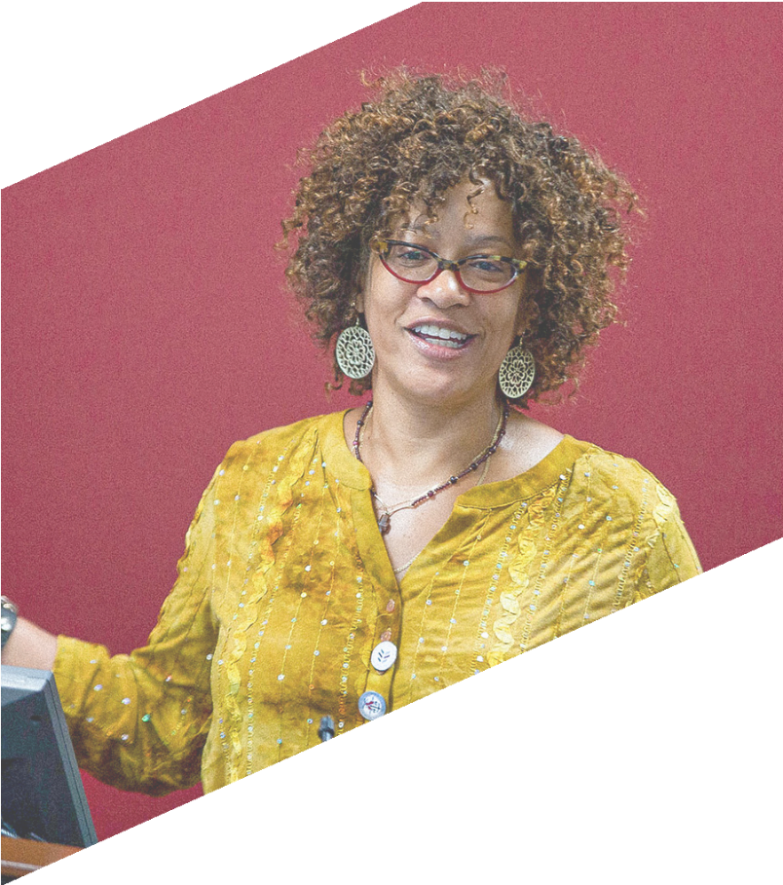

    - How will you prioritize your goals and align your actions to them?
    - What resources are needed to accomplish your goals? (i.e. funding, personnel, policies,
programs, legislation, etc.) This will inform your actions and timeline.
    - Do new programs, policies or tools need to be created to address the digital divide in your community?
      - See NDIA Digital Inclusion Manual for guidance.
  - Timeline: In developing your timeline, it will be difficult yet important to simultaneously address your community’s urgent needs (made more pronounced by COVID-19) with planning for the future and implementing long-term sustainable solutions. To develop your timeline, consider the following questions.
    - What resources are needed to accomplish your goals? For example, if you determine you need substantial funding to achieve your goals, you may need time to identify grant sources etc.
    - What is most urgent, pressing, and can be accomplished quickly (short-term)? (i.e. established within months)
      - Are there immediate situations that require a rapid response due to COVID-19?
      - Are there specific facets of your community that are in crisis due to the digital divide
and need immediate attention? (i.e. K-12 schoolkids attempting to participate in remote learning, etc.)
    - What can be accomplished soon (mid-term)?
(i.e. established within a year-18 months)
    - What will take more time (long-term)? (i.e. established within years, long-term sustainable solutions)

9

Worksheet/Notes

10

Worksheet/Notes

11

Created in collaboration with the National Telecommunications and Information Administration

For community planning use only.
DO NOT copy or modify.

