Any County Electric Cooperative

REQUEST FOR INFORMATION (RFI)

PROJECT: Last-Mile Broadband Development
ANY COUNTY CONNECT INITIATIVE

Any County Electric Cooperative
Address
Town, North Carolina 27***
Phone: 888-888-8888
Fax: 888-999-9999
info@emailaddress.com

REQUEST FOR INFORMATION
ANY COUNTY CONNECT INITIATIVE

RFI ISSUE DATE: July 12, 2016

RFI SUBMISSION DEADLINE: August 12, 2016, by 5 p.m.

Submit to:

RFI Contact Name: Contact Name, Title

Address: Address
Address
Address

Telephone: (888) 888-8888

Email Address: name@emailaddress.com

In addition, send a copy of all submissions and correspondence to the following:

Contact Name: Name, Title

Address: Address
Address
Address

Telephone: (888) 999-8888

Email: name@emailaddress.com

Introduction
Any County Electric Cooperative (ACEC) is a not-for-profit, member-owned electric cooperative with more than 14,500 metered accounts serving approximately 13,500 member-owners. The organization was chartered in 1938 and provides power to the rural areas of Alpha, Beta, Delta, Zeta, and Omega counties. REC has two business offices and 12 substations within their footprint. ACEC is upgrading the wide-area network (WAN) spanning its territory, connecting its substations via fiber optic cable to better manage the energy delivery services it provides. In conjunction with this effort, ACEC is looking for partners to use the excess capacity on its fiber to provide last-mile broadband service to residents, businesses and community anchor institutions within its covered counties, with a special focus on underserved and unserved constituents (customers with connection speeds less than the FCC broadband definition of 25 x 3 Mbps). Prospective partners should not only be able to provide sustainable initiatives, but be community-oriented and willing to develop solutions for the betterment of the region.
The region-wide fiber network, which consists of approximately 105 miles of fiber, is more than 50 percent complete, with total completion expected by the end of 20**. In addition to supporting the needs of ACEC, excess capacity on the fiber backbone can be used to support the needs of other community-enhancing programs, and will not be limited to solely providing broadband services to the rural and unserved/underserved areas of the region. For this purpose, ACEC has established Any County Connect Holdings, LLC (Any County Connect) – a fully owned subsidiary to manage and facilitate the development of community partnerships with those entities interested in using the excess capacity of the ACEC fiber network. A detailed map of the region and locations of the fiber network appears as Attachment A.

Project scope

Any County Connect is issuing this Request for Information (RFI) to identify potential partnerships with broadband providers and other interested entities to support the development of high-speed broadband infrastructure and services within the underserved and unserved regions of Alpha, Beta, Delta, Zeta, and Omega counties. This RFI is being released with the intent of generating interest from various entities wishing to use the ACEC fiber backbone to develop and implement new broadband services or enhance existing services, and who are willing to partner with Any County Connect to meet these ends. Potential customers include the 13,500 ACEC member-owners as well as existing and future businesses, public institutions, educational institutions, and healthcare facilities that fall within ACEC’s service territory that might otherwise be served by another electric service provider. Any County Connect is seeking network solutions and business models that are innovative and that prepare the region for future technological innovations while serving today’s needs for higher speeds, more complete coverage, and a wider range of choices for consumers.
The Any County Connect network will provide increased dark fiber capacity in this region, to be utilized by an array of future partners. This RFI, however, is focused specifically on last-mile partners. It is anticipated that both fiber-based and wireless-based solutions will be presented in the RFI responses; both will be considered. It should be noted that ACEC fiber intersects with the MCNC statewide open-access fiber backbone in several locations. In addition to the 105 miles of Any County Connect fiber, more than 100 miles of MCNC fiber is also installed in the northern sections of the five-county region. This fiber may also be available to interested parties under a separate agreement with MCNC.
The goals of this initiative are:
- Establish partnerships between Any County Connect and interested providers for the betterment of the communities involved and for quality of life enhancements.
- Facilitate the development of cost-effective broadband into the underserved/unserved areas of the five counties specified.
- Enable the deployment of state-of-the-art technologies, services, and applications that are often found in more developed urban areas but may not be currently available within the region.
- Create a competitive advantage for the region with respect to economic development, job creation, and growth opportunities.
- Consider the development and expansion of cellular services into unserved areas of the five counties.
- Provide an open-access architecture that enables the deployment of last-mile fiber and wireless technologies.
- Provide a collaborative foundation to serve the region for the foreseeable future.
To reach these goals, Any County Connect will provide vendors with access to a negotiated number of strands of existing optical fibers it owns or controls at negotiated rates. The network fiber optic cable is single-mode cabling as manufactured by Corning Incorporated, with installed capacities ranging from 72 to 144 fiber strands. Roughly 85 percent of the network is aerial while 15 percent is underground. See Appendix for fiber specifications.
Any County Connect fiber will allow for interconnection to fiber that may be owned by others in the region, including the MCNC fiber network. Interconnections will be made available at strategically located Points of Presence (POPs) or co-location points. POPs and co-locations can be strategically located within towns and other desirable locations within each community. Access can be provided at convenient locations along the entire fiber route to accommodate rural access using splice and maintenance loops installed at approximately 1,500-foot intervals across the network. Additional access points may be made available.

Other assets and facilities to be made available

In addition to fiber-optic capacity and co-location space within the deployed fiber network that Any County Connect will provide to vendor(s), other assets, services, and infrastructure owned by ACEC may be required. These assets include but are not limited to utility-owned conduit, fiber, poles, substations, rack space and other assets. Among these assets are two ACEC-owned towers – an approximately 300-foot radio tower near the ACEC headquarters in Delta and an approximately 130- foot tower at the REC campus in Alpha Square. Additionally, there is an antenna mast of approximately 70 feet located at each of the ACEC substations.

Grants and other resources
Any County Connect is interested in identifying and securing grants that can be directed to broadband expansion and development in the region. Further, Any County Connect may be able to provide vendors with assistance in applying for available grants or loans as needed to pay for network expenses. Any County Connect, through ANEC, may also be able to leverage relationships with local county governments to utilize existing resources, such as water towers and radio antennas.

Project location
The Any County Connect network is under development in northeastern North Carolina. The map on the following page shows the geographic region outlined in white, in comparison to the rest of the state.

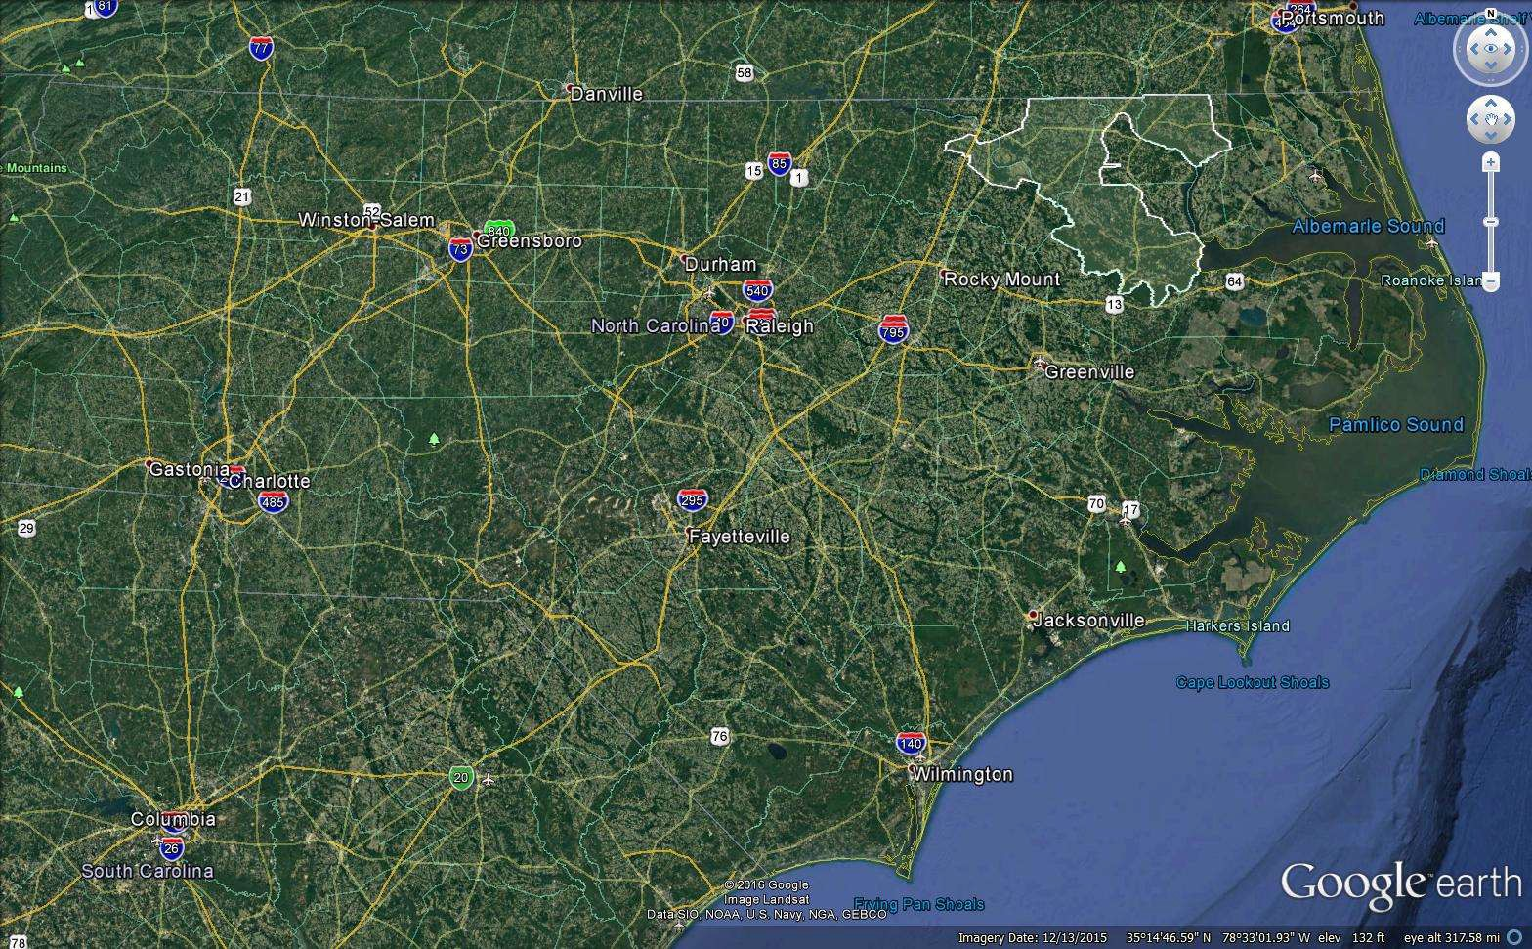

Combined with the MCNC portion of the network, the network will run through the five counties listed below. The map directly following this list shows the ACEC fiber in yellow and the MCNC fiber in red. A KMZ file of these routes can be made available with the RFI for responders’ review and modeling.

County | Total  Population (2010) | Median Household  Income (2010) | Rural vs.  Urban
Alpha | 54,691 | $30,861 | Rural
Beta | 22,099 | $32,168 | Rural
Delta | 21,282 | $30,586 | Rural
Omega | 24,669 | $32,410 | Rural
Zeta | 12,197 | $43,010 | Rural

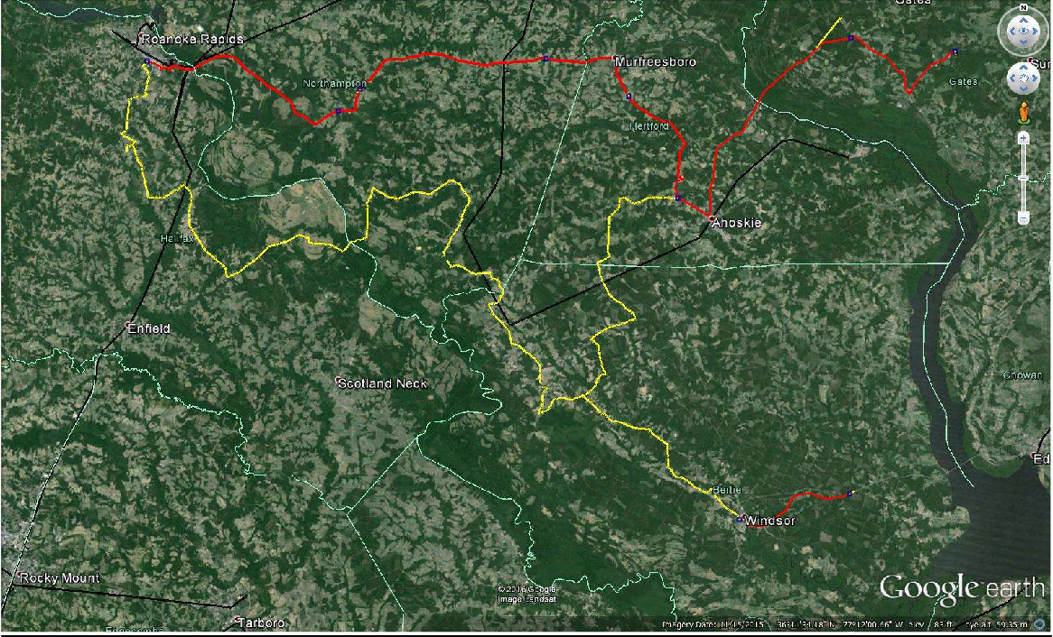

The fiber connects at ACEC substations with splice points located along the route for easy access to the fiber. Much of the new build route runs along utility poles owned and maintained by ACEC, with underground installations as needed. These poles, approximately 16-18 per mile, are roughly 30-35 feet high. Within the towns, the poles may be owned by other utility providers than ACEC. The fiber routes allow for the creation of ring architecture solutions and are enhanced by multiple interconnections with the MCNC statewide fiber network. The routing of the fiber was selected based on several factors:
- Energy services delivery points where monitoring is desired by ACEC.
- The ability to reach the largest number of communities in the region.
- Support of public safety, education, healthcare, municipal and economic programs.
- Making logical connections into the MCNC network.
- Build costs and maintenance cost.
- The ability to serve the greatest need.
- The ability to fill the gaps where effective infrastructure may be lacking.

Scheduled timeline
The Any County Connect network is expected to be completed by the end of 2016, with the MCNC portion of the network already in place. Through this RFI, ANEC is looking for a primary last-mile partner, or partners, to build out in this region, with the goal of having initial pilots underway in the coming months. Responders are encouraged to provide project milestones, locations, and delivery schedules as to project roll out and expected access to Any County Connect assets. Respondents should also include information on whether they believe a pilot is needed, based on their proposal, and the proposed timeline for the pilot.

Process and criteria for evaluation
Only those responses received by the stated deadline will be considered. All information submitted by the deadline will be reviewed and evaluated. Responses that lack sufficient information may cause ACEC to disqualify that vendor from consideration for partnership.
ACEC shall reserve the right to cancel, suspend, and/or discontinue any proposal at any time they deem necessary or fit without obligation or notice to the proposing vendor. Key selection criteria selection shall include:
- Quality of response
- Extent of the service area and services to be offered
- Technical quality of design and support plan
- Experience of project team
- References
- Vendor(s) experience
- Financial strength of vendor(s)
- Feasibility of vendor(s) financial response.
Further consideration shall be given to the following:

Provider Solutions
Vendors are encouraged to propose solutions that provide coverage over the full ANEC service area. If a vendor chooses to propose for a region less than the whole, the vendor must provide details as to the specific service area(s) for which it is proposing, including technologies proposed and explanation of ACEC assets most needed to make the solution feasible. Any County Connect may make the dark fiber and other assets available through a number of different strategies, including but not limited to IRUs, leases, and revenue sharing. Responders are encouraged to submit other strategies for consideration.
Responses should also include details on proposed pilots, if needed, and roll out schedules. Vendors shall include the use of maps or other diagrams as necessary to sufficiently allow Any County Connect to review the vendor’s solution. Vendors should describe by proposed service area, the last-mile services to be provided, including capabilities expected to be available to the entities within the proposed area of service. The service area is defined as the geographic area within which the proposed network solution will be deployed. Services to be provided are defined as the type, level, and capacities of the services that the vendors anticipate providing to end customers (e.g. 25 x 5 Mbps fixed wireless, 100 x 100 Mbps FTTH, etc.).
Vendor qualifications
Vendors must demonstrate and provide evidence of the following in their responses:
- Experience in high-speed network design and operation. Vendors should provide a statement of experience highlighting similar network systems that it has designed, constructed, and operated, including project name, location, size, technology used, and names and phone numbers for reference contacts. Also, the response should indicate whether each system is owned by the vendors or another entity. Any experience in partnering with electric cooperatives, or designing systems utilizing electric assets (poles, etc.), should be noted.
- Financial stability. Vendors shall submit the two most recent annual audited financial statements to permit analysis of financial resources.
- Staff technical and managerial experience. Vendors should include a statement of experience and resumes of key members that would be involved in a project.
In addition to the above criteria, the evaluation team will examine the extent to which each response meets the criteria below, which are not listed in order of importance. The evaluation team will then undertake a comparative assessment of all responses to decide as to which responses should be selected for further analysis and negotiation. These additional criteria include:
- The extent to which the response meets the objectives for the networks (as set out in Section 2);
- The capability of the vendor or coalition of vendors to design, construct, finance, maintain, support, upgrade, and operate the networks;
- The nature, scope, and impact of any legislative and/or regulatory changes (state or local) that are necessary to facilitate the response;
- The extent to which the response departs from the RFI and from Any County Connect’s proposed terms; and
- The location and size of the service area that a vendor is proposing.

Project proposal expectations
Any County Connect shall review and award at its own discretion a contract or contracts to vendors whose responses best accommodate the various project requirements. Any County Connect reserves the right to negotiate partnerships and award contracts to more than one responder and refuse any response or contract without obligation to either ANEC or to any vendor offering or submitting information.

Proposal deadline
All proposals must be received no later than the RFI Submission Deadline for consideration in the project proposal selection process. Responses received after the deadline will not be considered. Responses must be submitted electronically, or via priority or certified mail, to the addresses listed on Page 2 of this RFI.

Proposal submission format
The following is a list of information that the Vendor should include in their proposal submission:
  - Vendor’s name(s)
  - Vendor’s address
  - Vendor’s contact information (and preferred method of communication)
  - Legal form of vendor (e.g. sole proprietor, partnership, corporation)
  - Vendor’s Federal Employee Identification Number (FEIN)
- Evidence of legal authority to conduct business in North Carolina (e.g. business license number)

Acknowledgements
Construction
Vendors are responsible for all costs for construction of fiber or other assets as needed in areas where need/demand exists but no current asset is available. In such scenarios, the vendors may also contract with Any County Connect to assist in the construction of new fiber or assets. These fees will be negotiated between the vendors and Any County Connect as necessary.

Availability of Fiber
Any County Connect will make fiber and other assets available through a number of different strategies, including but not limited to IRUs, leases, and revenue sharing. Responders are encouraged to submit other strategies for consideration. Review and acceptance will be the sole responsibility of Any County Connect.

Rights of Way
Construction and installation of equipment in the ANEC, state, local, and independently owned rights of way will be subject to the applicable requirements and ordinances governing ROW and easements. Vendor(s) will be responsible for securing all needed rights of-way, easements, franchise agreements, etc. needed to implement proposed solutions.
The ANEC may allow vendors to have access to necessary rights-of-way on property owned by the REC and property on which it has an easement and authority to allow such access. Requested access will be reviewed and negotiated in accordance with the applicable requirements or ordinances.

Vendor Relationship
The relationship between the vendor and the ANEC/Any County Connect shall be that of a vendor. ANEC and/or Any County Connect shall share no liability of the vendor’s cost structures and/or services provided unless identified, negotiated, and agreed to up front by all parties in writing. Unless otherwise negotiated, approved, and documented by Any County Connect, the vendors selected shall bear all capital costs of the solutions proposed and implemented by said vendor, including but not limited to design, engineering, construction, and equipment costs for the networks up to the end-user drop points or network interface devices. In addition, vendors will bear all operating and maintenance costs, including insurance costs and relevant taxes. Vendor(s) should also demonstrate a clear and continuous upgrade path for the networks and their ability to meet future consumer demand and service departments.

10
Appendix

Fiber optic specifications

Central Element | Dielectric
Fiber Count | tbd
Fiber Coloring | Blue, Orange, Green, Brown, Slate, White, Red, Black, Yellow, Violet, Rose, Aqua
Fibers per Tube | 12
Number of Tube Positions | tbd
Number of Active Tubes | 12
Buffer Tube Color Coding | Blue, Orange, Green, Brown, Slate, White, Red, Black, Yellow, Violet, Rose, Aqua
Buffer Tube Diameter | 2.5 mm ( 0.1 in)
Tape | Water-swellable
Number of Ripcords | 1
Outer Jacket Material | Polyethylene (PE)
Outer Jacket Color | Black
Maximum Fibers per Tube | 12
Temperature Range
Storage | -40 °C to 70 °C (-40 °F to 158 °F )
Installation | -30 °C to 70 °C (-22 °F to 158 °F )
Operation | -40 °C to 70 °C (-40 °F to 158 °F )
Mechanical Characteristics Cable
Max. Tensile Strength, Short-Term | 2700 N (600 lbf)
Max. Tensile Strength, Long-Term | 890 N (200 lbf)

Weight | 162 kg/km (109 lb/1000 ft)
Nominal Outer Diameter | 15.8 mm (0.62 in)
Min. Bend Radius Installation | 237 mm (9.3 in)
Min. Bend Radius Operation | 158 mm (6.2 in)
Chemical Characteristics
Optical Characteristics (cabled)

RoHS | Free of hazardous substances according to RoHS 2002/95/EG

Fiber Name | Single-mode (OS2)
Fiber Category | G.652.D
Fiber Code | E
Performance Option Code | 01
Wavelengths | 1310 nm / 1383 nm / 1550 nm
Maximum Attenuation | 0.4 dB/km / 0.4 dB/km / 0.3 dB/km

